**Final Report for Team Satisfeed**

**Project Description:**

Team Satisfeed partnered with the nonprofit organization Satisfeed, which delivers hunger relief for Gwinnett’s families in need. With their food co-op and weekend support programs, they work to fight food insecurity and reduce food waste. Their mission is to feed people and connect communities. The team was tasked with developing a data-driven dashboard to visualize client demographics and service usage statistics. Using Google Colab for data analysis and Power BI for dashboard development, we designed an interactive tool that allows the organization to better understand the needs of its clients and make informed decisions about program planning and resource allocation. This project highlights the potential of data science to empower nonprofit organizations in their mission to create meaningful social impact while being able to visualize said impact.

**Team Members and photo:**

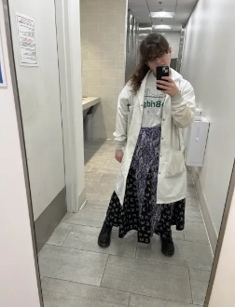 

Caleb Cedeno Elizabeth Doss Damaris Montecinos

**Client Presentation:**

Client: Tim Turner

Tim Turner is the founder and CEO of the nonprofit organization Satisfeed, who we worked with to come up with a dashboard for Satisfeed’s website.

**Team Plan:**

Our team used Jira to plan our sprint and used it to manage our task throughout the project. Our group meetings with the team were held through discord and communication with each member was through discord or email. Communication with our client was through email and Zoom. Our main task given by our client was for our dashboard to generate visualization of their client demographics and statistics to improve services. We each had a role, Damaris was in charge of cleaning our data, Elizabeth was in charge of analyzing the data, and Caleb was in charge of visualizations of the data. Together we were able to come up with a dashboard to present to our client and to present at STARs and CREATE.

**Roles:**

Caleb Cedeno- Project Manager, Visualizations

Damaris Montecinos- Data Modeler, Project Documenter

Elizabeth Doss- Data Analyzer, Client Liaison

**Technologies used:**

The main technologies used were Google Colab, Python, GitHub, & Power Bi

**Flow chart of the Project:**

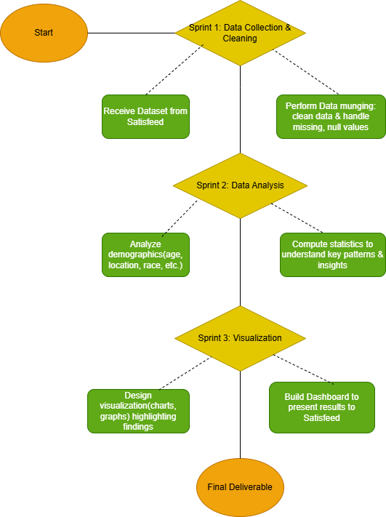

**Collection, including link:**

* + We will not be putting the dataset that Satisfeed provided to us since it contains sensitive and personal information of Satisfeeds clients such as name, address, and phone numbers’
  + Dataset will be emailed to Dr.Anca as well as the final Notebook

**Methods used to clean the dataset:**

* Used python to handle missing and irrelevant data.
* Missing values were addressed by filling them with appropriate placeholders: Unknown’ for blank entries, NaN for missing numerical values, and TRUE or FALSE for Yes/No entries.
* Columns with insufficient data or those deemed unnecessary based on client priorities were dropped
* Clean data saved to a new CSV file and JSON file

**Methods used to analyze data, and results as statements and plots:**

**Techniques Used:**

* For data analysis we looked at key demographic features of Satisfeed clients such as location and employment status.
* We attempted principal component analysis (PCA) and linear regression to find connections, but did not find significant or unexpected results

**Results:**

* Most people appear to be asking for assistance only once, but there are people asking upwards of ten times.
* The biggest racial Demographic that Satisfeed helps is the ‘Hispanic, Latino, or Spanish Origin’
* The majority of Satisfeed’s client status are Part time, Full time, or Unemployed
* A big majority of Satisfeed’s Clients come from Outside of Gwinnett County
* Attempted PCA and Linear Regression but did not find significant or unexpected results
* A majority of satisfeed clients household income is under $25,000
* The most assisted age group is 41–50-year-olds and a majority of them are Hispanic

**Plots:**

* A graph with blue bars

  AI-generated content may be incorrect.
* A pie chart with different colored circles

  AI-generated content may be incorrect.
* A bar graph with text

  AI-generated content may be incorrect.
* **A green circle with a line in the middle

  AI-generated content may be incorrect.**
* 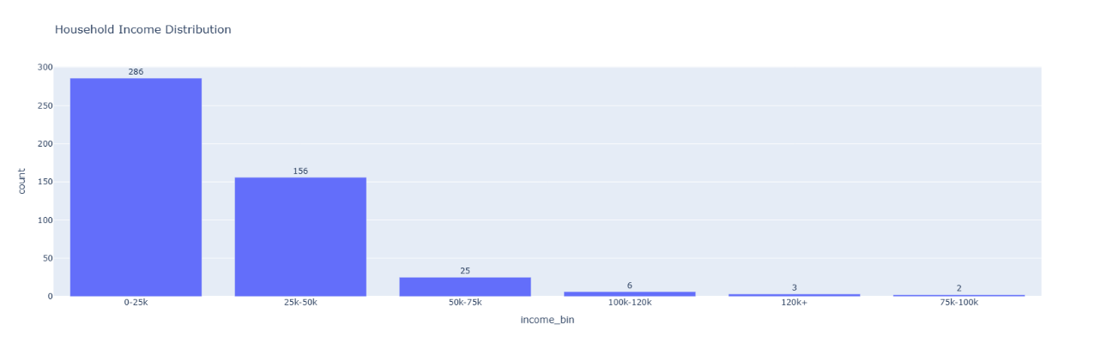
* 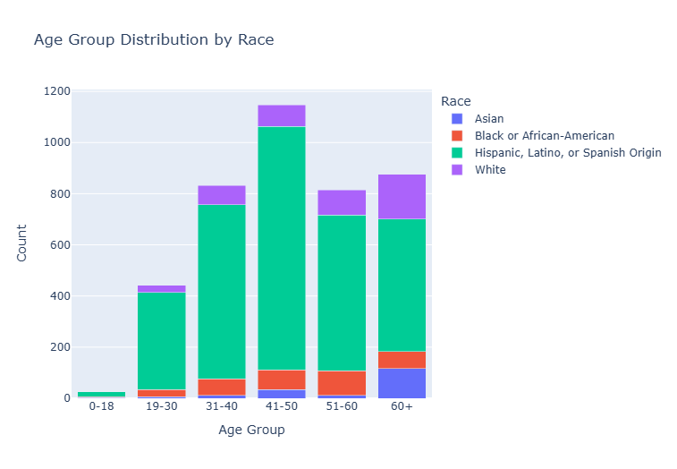

**A summary of each iteration's results:**

* **1st Iteration:**

For the first iteration, our team received a dataset from Satisfeed that contained sensitive private information. The dataset was missing many values, so we had to clean the data before we could use it. Our data modeler was in charge of cleaning the data by using python to handle missing and irrelevant data. Missing values were addressed by filling them with appropriate placeholders: “Unknown” for blank entries, NaN for missing numerical values, and TRUE or FALSE for Yes/No entries. Columns with insufficient data or those deemed unnecessary based on client priorities were dropped. We saved the clean dataset to a new csv file.

* **2nd Iteration:**
* For the second iteration we were focused on analyzing our data. Our client wanted to know more about Satisfeed’s demographics and statistics. Our data analyzer focused on analyzing the data by using the clean data we were able to come up with Assistance request frequency, ethnic/racial plot, client status plot, zip code analysis, household income distribution, and Age group distribution by race plot. Our data modeler attempted PCA and linear regression but did not find significant or unexpected results. Our data visualizer used these plots to start coming up with ideas for our dashboard.
* **3rd Iteration:**

For the third iteration we finalized our project by creating the dashboard. Our data visualizer was able to take the plots we created in iteration two and 1 to 1 it onto the power BI dashboard. We decided on which plots we wanted to put on the dashboard and how we wanted it to look before presenting the final version to our client.

**GitHub repo link and a short overview; link to deployed project on Github Pages:**

* Github link: <https://github.com/GGC-DSA/Satisfeed>
  + Overview:
    - The Power BI Dashboard will be linked in the README.md
    - The notebook and datasets will not be linked in Github as it contains Satisfeed’s clients sensitive and personal information such as names, addresses, and phone numbers.
* Power BI dashboard link : <https://app.powerbi.com/view?r=eyJrIjoiMGViYzE1YzktZmEzNi00OTJhLThhNWQtZDRkMjczOTZlNzAxIiwidCI6ImNmOTU1MmRiLTY2MGEtNGE5MS05YmQ2LTY1YzIzMDBmOWNiMSIsImMiOjF9>
* Project Website link: <https://satisfeeddashboardproject.carrd.co/>

**Jira dashboard up to date, along with burndown and velocity charts (from all 3 iterations):**

* Sprint 1 Burndown chart: A graph showing a line

  AI-generated content may be incorrect.
* Sprint 1 Velocity chart was not captured as we didn’t give task story point estimates.
* Sprint 2 Burndown chart: A graph with red line

  AI-generated content may be incorrect.
* Sprint 2 Velocity chart: A graph with a green and blue line

  AI-generated content may be incorrect.
* Sprint 3 Burndown chart: A graph with a line going up

  AI-generated content may be incorrect.
* Sprint 3 Velocity chart: A graph with a green and grey bar

  AI-generated content may be incorrect.

**Provide a short screencast demoing your product live:**

* <https://drive.google.com/file/d/1wWbONNjA1nQVKGMn-H32ejXzWbqeBAmy/view>

**List of features implemented:**

* We created demographic and statistic visualization onto the dashboard
  + Race distribution pie plot – showing the percentage of each race that come to satisfeed for assistance
  + Income distribution by bins plot- showing the income that the clients fall into
  + Employment status plot- showing Satisfeeds client’s employment status
  + Education achieves plot- showing Satisfeeds clients education level achieved
  + Managed to show a count of how many clients satisfeed has
  + Created a heatmap to show where clients are coming from

**List of known issues:**

* As of now the only known issue we have is uploading the dashboard onto the website, since Power BI does not let us upload it unless we pay.

**List of TODO tasks that remain unsolved for future teams to work on (TODO.md file must be in the repo):**

* The client would like the "lbs of food served" card to be real time where they can live update the data
* A refinement of zip code data and attempt to “Geolock” visualization
* The final dashboard going live on the Web
* Client asked for weekly food distribution value, this came up at the end of our project during CREATE.
* Client asked for a Age metric Distribution. Most ages come from registrees, so this would involve creating a new field capturing the age of the dependents. This also came up at the end of our project during CREATE.